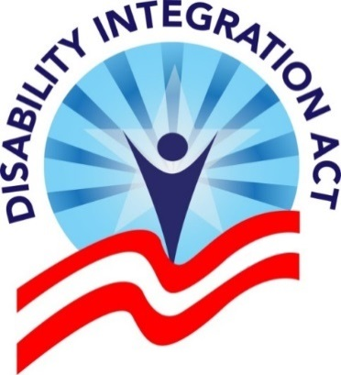
The Disability Integration Act
Over 25 years after the signing of the Americans with Disabilities Act (ADA), institutionalization seriously interferes with the liberty of people with disabilities and seniors. The Senate HELP Committee report “Separate and Unequal: States Fail to Fulfill the Community Living Promise of the Americans with Disabilities Act” documented the failure of States to secure and protect the liberty of people with disabilities and seniors by refusing to provide community-based services. That report recommended that Congress strengthen the ADA integration mandate to clarify that States and private insurers cannot interfere with every American’s right to liberty by failing to provide Long Term Services and Supports (LTSS) in the community.

Summary of Legislation
The Disability Integration Act ensures that people with disabilities have a right to live and receive services in their own homes. The DIA further secures our Constitutionally protected right to liberty by preventing disabled people from being forced into costly institutional settings by unnecessary government regulations.

Legislative Approach
The Disability Integration Act (S.117/HR. 555), introduced by Minority Leader Schumer (D-NY) and Congressman Sensenbrenner (R-WI), and supported by Senator Cory Gardner (R-CO), Senator Elizabeth Warren (D-MA), Congressman Rep. Ken Buck (R-CO) and Congressman John Lewis (D-GA) and many more, creates a comprehensive solution, assuring the full integration of disabled people in the community by:
- clarifying that every individual who is eligible for LTSS has a federally protected right to a real choice in how they receive services and supports;
- assuring that states and other LTSS insurance providers deliver services in a manner that allows disabled individuals to live in the most integrated setting, have maximum control over their services and supports, and lead an independent life;
- articulates the right to live in the community without creating unnecessary or wasteful Government programs; States have broad latitude to determine how they will secure that right;
- establishing a comprehensive planning requirement that includes enforceable benchmarks;
- requiring public entities to address the need for affordable, accessible, integrated housing that is independent of service delivery; and establishing stronger, targeted enforcement mechanisms.

Why You Should Support DIA
THE RIGHT TO LIVE IN THE COMMUNITY is logically prior to, and necessary for, the exercise of the rights which the ADA was intended to secure for all people with disabilities.
The lack of adequate community-based services and supports has imperiled the civil rights of all people with disabilities, and has undermined the very promise of the ADA.
It is, therefore, necessary to recognize in statute a robust and fully-articulated right to community living.

- It secures the Constitutional right to liberty for millions of disabled people and seniors who are in institutions and want to live in the community.
- It helps aging seniors stay in their own homes.
- It saves millions of Federal and State dollars compared with institutionalization.
- It keeps families together.

Support for this Legislation
This legislation has broad-based support of organizations with over 100 national groups, and over 600 groups in all. It was crafted by ADAPT & the National Council on Independent Living with assistance from the Autistic Self Advocacy Network. Key supporters include:

- ACLU
- American Association on Health and Disability
- American Association of People with Disabilities
- Association of Programs for Rural Independent Living (APRIL)
- Association of University Centers on Disabilities
- Bazelon Center for Mental Health Law
- Brain Injury Association of America
- DREDF
- Lutheran Services in America Disability Network
- MS Society
- National Academy of Elder Law Attorneys
- National Council on Aging
- National Disability Leadership Alliance
- National Downs Syndrome Congress
- National Organization of Nurses with Disabilities
- Paralyzed Veterans of America
- Parent to Parent USA
- TASH
- The Arc of the United States
- The Congress of Disabled Persons Against Exploitation
- United Spinal Association

This issue has significant untapped public support. In 2010, ADAPT secured a Harris poll assessing public support. The poll showed that 89% of all Americans, and 94% of retirees, support legislation which would require people to get home and community-based supports and services instead of forcing older and disabled Americans into nursing facilities and other institutions.

More information, including the full supporter list, is available at the DIA website: www.DisabilityIntegrationAct.org

